Type of plant: SOLAR THERMAL SYSTEM

Place: Montecchio Maggiore (VI), Italy – Changing rooms of the football field

Surface of the solar thermal collectors: 40 m²

Store: 3000 lt.

Plant description: coplanar installation on the cement roof. It is a forced-circulation plant with flat-plate collectors for the production of hot water.
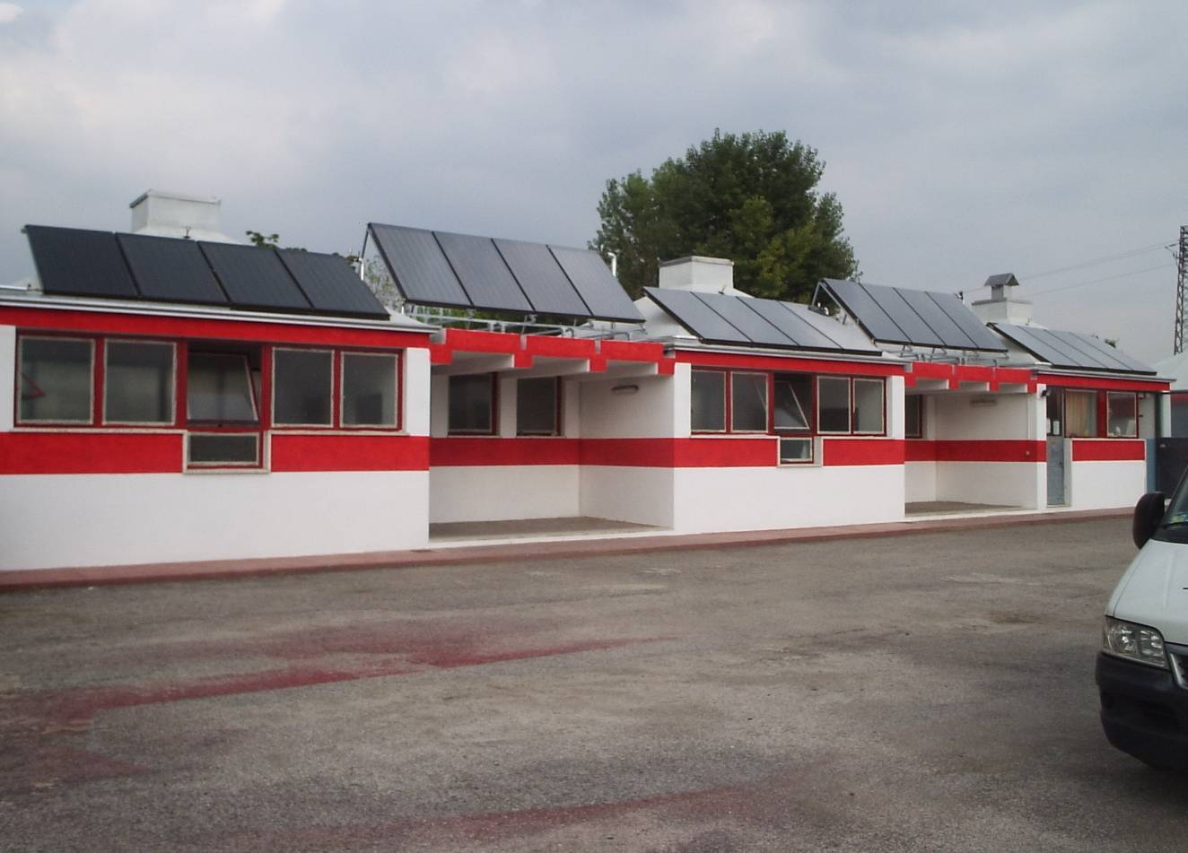

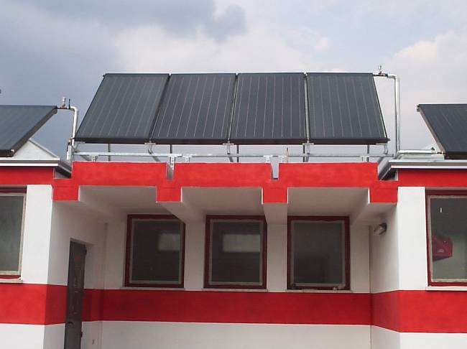
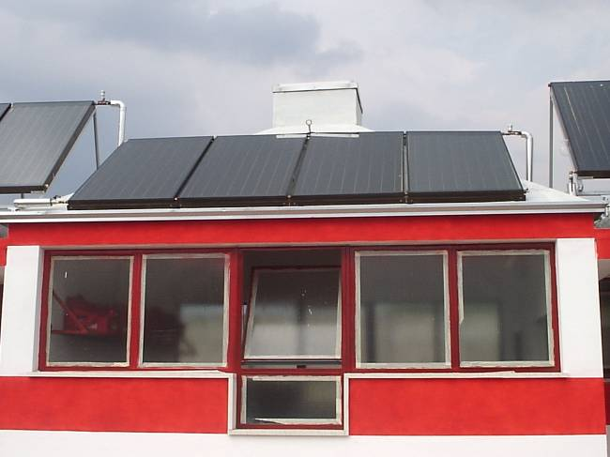

Year of installation: 2005

